Capay Valley Projects Proposed for the Yolo Subbasin Groundwater Sustainability Plan
May 2021

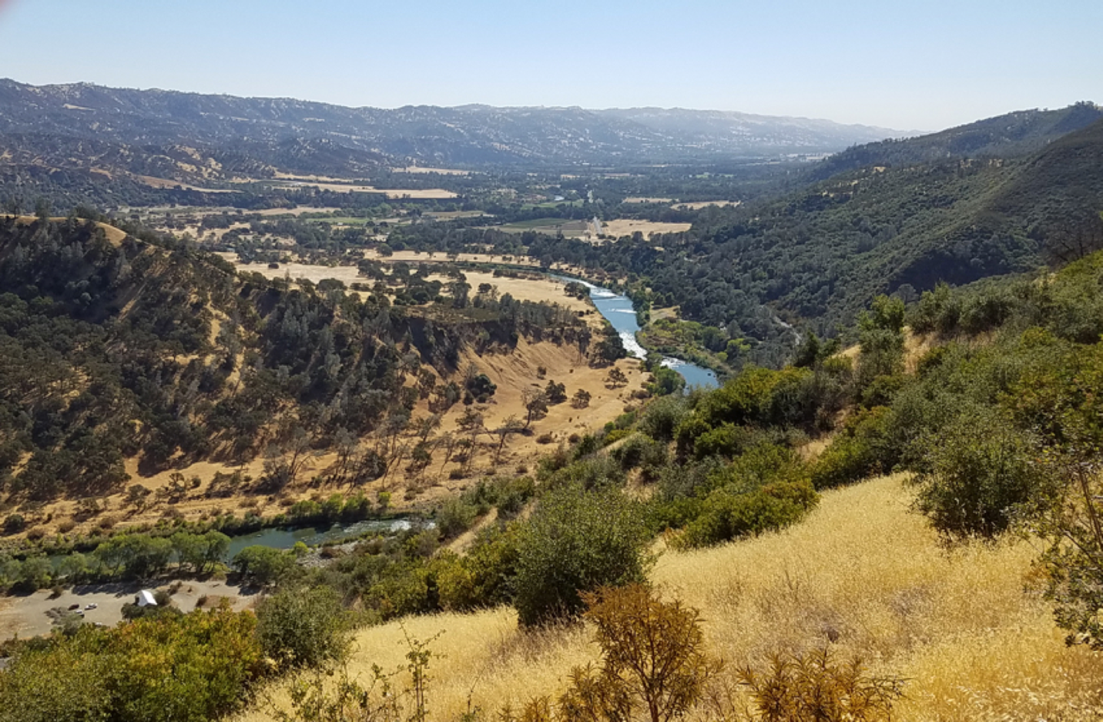

Vision for 2050

We love and cherish our beautiful and unique Capay Valley, and would like, through actions to be undertaken under the GSP, assure its long-term integrity and ecological functioning for the benefit of present and future generations. To this end, it is paramount that we the people of the Capay Valley live in harmony with nature’s endowments, the natural resources available on a renewable and regenerative bases. The forecast on several of these natural resources, in particular water and biodiversity are a concern and need to be addressed head on and without delay. Overuse of groundwater may lead to irreversible damage to the soil’s recharging ability and jeopardize agricultural production. In addition, climate change, and the increase number of extreme events, droughts, floods and fires are adding to the challenge of keeping our Valley not only productive but also a destination for people seeking peace in a conducive and relaxing environment.

By working together as a community aware of the issues and knowledgeable about solutions on a grand plan for restoring, maintaining and increasing the unique Valley’s agricultural and environmental attributes, starting with the perhaps most constraining element, water, the people of the Capay Valley will assure that their children and grandchildren will enjoy not only the same benefits, but thanks to a regenerative approach create lasting improvements.

Background

Capay Valley is a largely rural valley northwest of Sacramento in Yolo County, California, United States. It lies east of Blue Ridge and west of the Capay Hills. Cache Creek flows through the valley.

Before settlement by Europeans, Cache Creek meandered through Capay Valley, with grassy floodplains at many turns. In times of high flows, flood waters traditionally spread across the landscape, depositing sediments and nutrients, resulting in a relatively rich soil in the valley floor. The Capay Hills and Blue Ridge Mountains, covered by oaks and pines at higher elevations and native grasses and shrubs below, provided watershed services, absorbing a good proportion of rainfall, and channeling the runoff into multiple small creeks feeding into Cache Creek.
Managed by native Americans who had fashioned a reciprocal relationship with the plant and wildlife communities, the Cache Creek watershed and most of California was some of the most productive in the world, providing a bounty of food, medicine, fiber and building materials. Over the last hundred years and more, the hillsides of the watershed have lost a considerable amount of tree cover, and there has been some erosion in intermittent waterways. But the basic ecosystem is strong and intact, and it is the hope of residents in the Valley – formed into a Capay Valley Regeneration Project – that ways of managing the watershed can be supported that maintain sustainable groundwater levels while reaping multiple benefits, such as making the Valley more fire resilient, and improve soil and hillside water retention capacity, in the face of climate change challenges.

An integrated package of biological/ecological projects to enhance the hydrological functioning of the Capay Valley

- Improved hydrologic flows
The specific projects proposed at this time for this element include:

1.a.1 Conservation Hydrology Assessment and Design

Justification: Capay Valley Management Area is a key component, not only of this important agricultural valley’s water resources, but of the Yolo Subbasin’s watershed, including surface and groundwater resources (Figure 1.a.1). There is potential for watershed actions within the management area that can have substantial impacts locally and throughout the Subbasin. To develop a clear focus on those actions that can have the greatest impact, a watershed-wide assessment is needed to create a design that can estimate the groundwater recharge benefits from each proposed project and for the whole - identifying any synergy among the projects - assess priority opportunities for the greatest groundwater recharge (at least cost) and develop a monitoring framework for projects implemented (monitoring projects are noted in blue in each narrative).

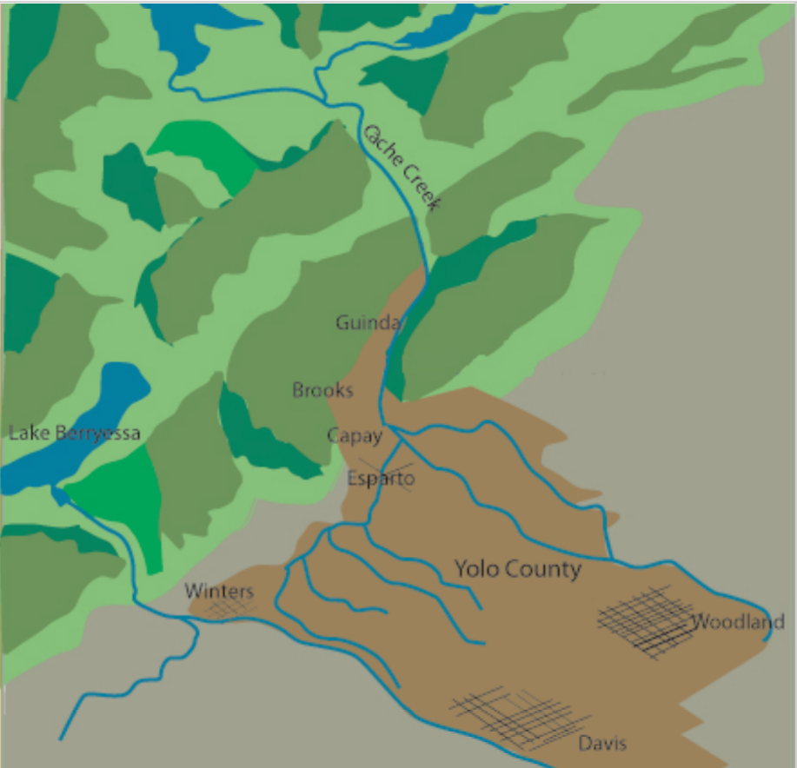
Figure 1.a.1 (illustration redrawn from

1.a.2. Demonstration sites for capturing hillside run-off

Justification: The Capay Valley watershed includes many large ranches managing the upland grasslands, oak woodlands and chaparral. Many have invested in ensuring the sustainability of these vast tracks of land through the California Rangeland Trust (https://rangelandtrust.org/our-priorities/#ConservingRangeland) or have introduced water conserving measures through small livestock watering sites and check dams. There remains a significant potential to explicitly manage the rangelands and upland areas of Capay Valley to increase water infiltration/retention in the hills through such measures such as keyline installations and natural sequence leaky weirs, land contouring, creation of wide swales to slow and capture water as it runs downhill, and selective planting/encouragement of native vegetation. The Soil Agricultural Groundwater Banking Index which rates banking potential based on five factors: deep percolation, root zone residence time, topography, chemical limitation, and solid surface condition can guide the siting of projects as the methods to increase infiltration/retention mentioned above can improve each of these factors except topography. Methodology to measure changes in infiltration and water holding capacity as well as increases in forage/animal production will be an integral part.

1.a.3. Scale up best methods for capturing hillside run-off

Justification: On the basis of the findings from 1.a.2. and the demonstration sites developed, these will be used for education and outreach to upland producers and restorationists, and a program will be developed to recruit hillside landowners to apply best practices for their specific situation. This may include identifying means of providing incentives to landowners to make land management changes. In some cases, measures of capturing hillside run-off might improve the topography factor that helps determine groundwater banking potential. Methodology to measure changes in infiltration and water holding capacity as well as increases in forage/animal production will be applied watershed wide.

1.b. Restore tributaries to Cache Creek

Justification: Experts have noted that the most immediate ways to increase groundwater recharge begins with increasing the time that surface water remains in streams or is capable of infiltrating in stream edges. This can be accomplished by excluding livestock from stream beds, using leaky weir technology in low slope areas to hold back water, and planting incised banks with native riparian vegetation. Both traditional fences and “fenceless grazing technology will be investigated. Methodology to measure if these measures reduce peak tributary flows after storms and if riparian habitat increases will be measured as proxies for increasing groundwater recharge.

1.c.1. Groundwater recharge from increased beaver colonization

Justification: There is considerable evidence (Pollock et al. 2013) that beaver dams can alter the hydrology and geomorphology of stream systems and positively affect habitat for biodiversity. Beaver dams measurably affect the rates of groundwater recharge and stream discharge, retain enough sediment to cause measurable changes in valley floor morphology, and can enhance stream habitat quality for many fishes. To understand how to apply this finding to the Cache Creek watershed, expert consultation will be sought to design an implementation plan for maximizing the groundwater recharge that beaver colonization could bring to Cache Creek by determining suitable sites given topography, land ownership and creek dynamics. Methodology to estimate changes in groundwater recharge from encouraging increased beaver colonization in Cache Creek will be developed.

1.c.2. Implement plan for enhanced beaver colonization

Justification: The implementation plan for maximizing the groundwater recharge that beaver colonization could bring to Cache Creek will be discussed with the community and riparian producers with riparian lands and implemented accordingly. Initial steps could simply involve education and outreach about ways to keep beaver from building dams in destructive places so that creek-front producers will not drive beaver away. Methodology to estimate changes in groundwater recharge from encouraging increased beaver colonization in Cache Creek will be implemented and tracked.

- Grazing management
2.a. Grazing demonstration sites for enhancing water infiltration and water holding capacity

Justification: While it may appear to be most strategic to target intermittent streams and upland waterways for groundwater recharge (as above in 1.b, etc.) the vast scope of upland areas used for grazing are relatively untapped, and unknown for their groundwater recharge potential. The root zone, as depicted in Figure 2. could be vast and extensive in the upland areas. The benefits of groundwater management could be underestimated if limited to valley floor sites, given current estimates that every 1% increase can potentially increase water holding capacity by at least 20,000 gallons per acre. Source: https://www.nrdc.org/experts/lara-bryant/organic-matter-can-improve-your-soils-water-holding-capacity. Accessed May 24, 2021.
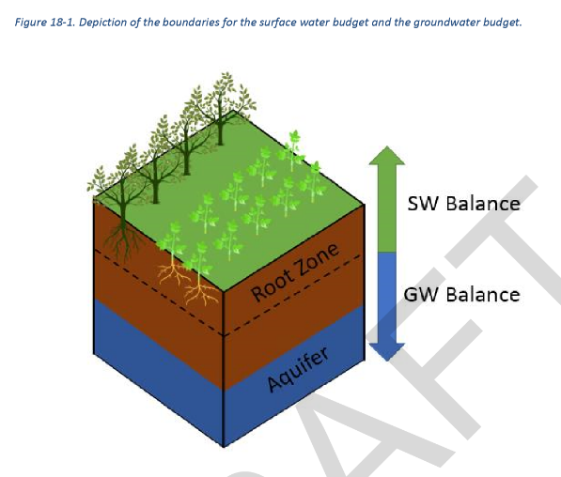

By managing two to five 100-acre sites through grazing management with approaches which have been shown to increase soil organic matter, the benefits of such management practices for groundwater recharge will be documented. Demonstration sites will conduct outreach, targeted to engage ranchers in adopting approaches to increasing organic matter and soil water holding capacity. The potential will be assessed for community herds rotated throughout the Capay Valley Management Area to attain such benefits on lands where year-round herds do not make economic or ecological sense. Methodology to estimate potential changes in groundwater recharge from selective grazing practices in each of the demonstration sites (with a variety of vegetation and slope) will be developed.

2.b. Scaling up demonstration site approaches with infrastructure support

Justification: Based on findings from 2.a, a major scaling up of the best practices in selective grazing management of uplands for groundwater recharge will be supported. Types of support to be provided to uplands landowners will include: a hub with expert consultants, an equipment bank for lending and maintaining equipment for which individual ownership is not economical, management and labor services, and support for fencing and establishment of plant cover in selected zones. Permitting for the installation of stock ponds will be facilitated as an incentive to adopt other practices the methodology as developed above - to estimate potential changes in groundwater recharge from selective grazing practices including stock ponds – will be applied to areas where the practices are scaled up.

- Crop production
Justification: Increasing attention is being paid, particularly in relatively arid areas of the West, to the relationship between runoff and recharge (Flint and Fline 2007). This relationship can be influenced by soil-water holding capacity and thus by land management practices that impact the ability of the soil to absorb and retain rainfall. The crop producers’ subcommittee of Capay Valley Regeneration have identified a key set of practices known to increase soil water storage and water infiltration including:

- Growing rain-fed cover crops in the winter;
- Adopting no till (experience from no-till farmer is that tilling destroys soil structure so that water runs quickly through the soil requiring more frequent irrigation;
- Seeding field edges with native grasses;
- Using mulch, compost, and BEAM compost for mycorrhizal inoculation.
- Assist growers with greater water-conserving measures.
- Provide a hub for exchange of equipment and expertise (see 5 below).

All of these practices are in use by some farmers in the cropland/valley bottom portion of Capay Valley. If applied in a strategic manner, with respect to the Conservation Hydrology Assessment and Design as described in 1.a.1 (above), the management of the valley bottom has the potential to be a greater source of groundwater recharge than it is already. Methodology to estimate potential changes in groundwater recharge from changes in crop production practices will be developed, through selective monitoring wells and applied as practices are documented and implemented.

- Strategic ecosystem restoration

4.a. Develop a restoration plan and restoration demonstration sites

Justification: The broader ecosystem of Capay Valley has been considerably altered over the last 200 years, from its original state of oak and chaparral covered hillsides to riparian floodplains and grasslands in the valley bottoms. In selected areas, these ecosystems can be restored to some of their original states and functions:

- Chapparal in the drier hillsides have been exposed to frequent fires; their plant communities are well adapted to both fire and drought, and some, such as manzanita, have intricate association with soil mycorrhiza that permit deep penetration of rainwater. The health of these association under more frequent fires than normal needs assessment.

- Oak woodlands in the moister uplands, with their accompanying deep-rooted perennial grasses such as Oatgrass, can permit greater water infiltration and storage increases; the status of their mycorrhizal and fungal associates merits a close assessment.

- Tree canopies in riparian zones – willows, cottonwoods and Valley Oaks – can create essential areas for groundwater recharge, slowing flows and allowing greater seepage. In many areas along Cache Creek, riparian areas have been overtaken by Arundo grass and Tamarisk invasives, contributing to water loss and the flammability of the Creekside. Restoration of these zones can have multiple benefits, to biodiversity as well.

A careful assessment of areas – chaparral, and oak woodland uplands, riparian forests that could provide multiple benefits should be made, including a measure of costs and groundwater benefits. Practices that enable restoration, including controlled burns and selective grazing, will be promoted. Restoration on a set of demonstration sites in each of these ecosystems should be initiated, and costs and benefits recorded.

4.b. Scale up strategic ecosystem restoration

Justification: Using data from restoration demonstration sites, producers and restorationists will be recruited for Capay Valley ecosystem restoration through outreach, education, and incentives. Several of the restoration practices may require coordination across the landscape and the involvement of different agencies, such ecologically timed prescribed burning, augmented with community grazing, which will also reduce fuel loads.

- Establish an Equipment and Knowledge Hub
Justification: A one-stop-service Equipment and Knowledge Hub will be established to make available services and equipment that support the projects described above and their application into perpetuity. Services and equipment will be tailored to the needs of livestock managers, crop producers and habitat restorationists. The aim will be to make available the knowledge and tools that are not readily available as yet and are necessary for farmers/ranchers/others to adopt practices for improving groundwater management. Each as listed below could serve as a project in its own right because any would improve groundwater management. However, the entire package would offer economies of scale and synergy:

- Purchase and maintain equipment needed to implement practices above but which do not make economic sense for individual farmers/ranchers/restorationist to own:
- Acquire a high capacity, stand-alone chipper/shredder for use by value farmers to turn excess wood to mulch;
- Establish innovative composting center such that farmers can contribute crop waste and cuttings, and processing can be centralized and automated as needed;
- Conduct intensive outreach and education;
- Contract with organizations like Cooperative Extension or RCDs or with private consultants to develop implementation and management plans using production practices that enhance soil organic matter water storage and percolation;
- Provide management services for farmers wanting to apply the practices for improved groundwater management, but who would want others to manage the practices;
- Provide labor services for landowners to implement plans;
- Manage California Healthy Soils applications;
- Be a repository of lessons learned to help landowners find solutions to any challenges (database application) they face in implementing groundwater sustainability practices;
- Devise and implement incentive schemes to enable landowners to implement measures, including ways of financing the additional labor needed, and the cost of native/cover crop seed or native plants.

Costs of each of these services and equipment provisioning will be included in the measurement of costs and benefits of each project above.

References cited

Pollock, M. M., Heim, M., & Werner, D. (2003). Hydrologic and geomorphic effects of beaver dams and their influence on fishes. In American Fisheries Society Symposium (Vol. 37, pp. 213-233).

Flint, L. E., & Flint, A. L. (2007). Regional analysis of ground-water recharge. US Geological Survey Professional Paper, 1703, 29-59.

